SUPPORT THE ZOO
Animal adoption is pleasurable and you can adopt any animal, no matter how big or small. The Adoption Programme enables individuals, corporations, schools, clubs, families and groups to participate and make a valuable contribution towards the care and enrichment of all the animals living at the City Zoo. Adoption fees help to take care of the animals and the money also goes towards the protection of endangered species. As a non-profit organisation we are in need of funds for supporting all species and upgrading facilities. In addition, your contribution provides the necessary help to advance the zoo’s work with wildlife conservation organisations worldwide. It also offers a rare opportunity to teach children and adults to take care of living creatures and to understand the environment that wild animals belong to.
You can help make a difference. An Adopt an Animal voucher is a wonderful gift for friends and family celebrations and for special occasions. Your adoption will last one year from the date of joining and is renewable on an annual basis, if you so wish. Below is a small selection list of the different animals and creatures you can adopt and enjoy at the City Zoo. All animals adopted are symbolic adoptions and will remain within the confines of the zoo. Animal choices are subject to change. If for any reason, the animal that you have adopted needs to be removed from the zoo, then your adoption will be transferred to another animal of your choice. We thank you in advance for your valuable contribution and for your ongoing commitment to the City Zoo.
List of some of the animals at City Zoo: Siberian tiger, lion, honey badger, pot-bellied pig, gorilla, ruffled lemur, snake, giraffe, hippo, rhino, elephant, axis deer, blue crane, monkey and many more.

Type of adoption sets
- R 300
  - Personalised Adoption Certificate
  - One free entrance voucher and paid parking
  - Photograph of your adopted animal
  - Species information
- R 550
  - Personalised Adoption Certificate
  - Two free entrance vouchers and paid parking
  - Photograph of your adopted animal
  - Species Information
  - Cap
- R 1 200
  - Personalised Adoption Certificate
  - Four free entrance vouchers and paid parking
  - Photograph of your adopted animal
  - Species Information
  - Your name appears on the main sponsor board at the zoo's entrance
  - Book and Cap
- R 5 000 - R10 000
  - Personalised Adoption Certificate
  - Six free entrance vouchers and paid parking
  - Photograph of your adopted animal
  - Species Information
  - Private keeper presentation
  - Adopted animal’s exhibit and cap

Share your love of animals by adopting your favourite animal at the City Zoo either for yourself, another animal lover, a friend or relative. It is both rewarding and fun! When you adopt an animal, your gift provides for the care and feeding of the animals and supports the City Zoo's ongoing commitment to global wildlife conservation. Your generous donation helps to make the City Zoo the best possible place for the animals to live, and for you to visit.

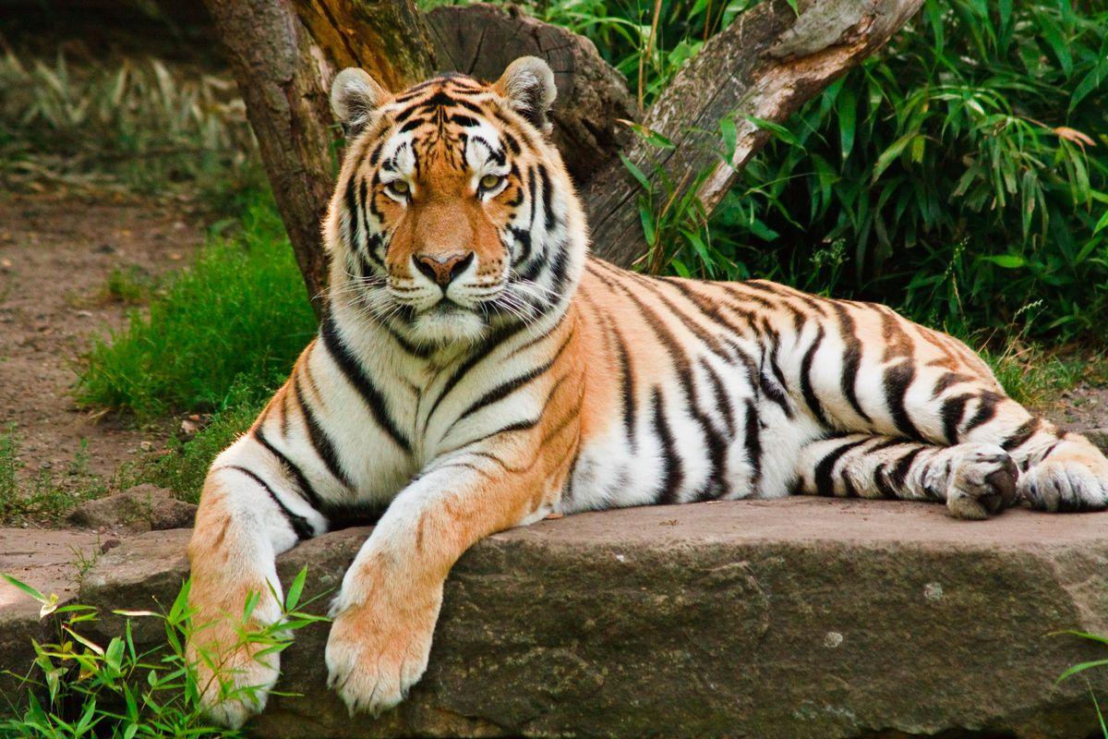
There are different kinds of adoption packages and what they contain depends on the adoption fee you will pay. Adoption packages include a minimum of entrance vouchers to the zoo, an adoption certificate and information about your animal. To participate, select your animal, fill out the adoption form below and send the completed form together with your proof of payment to: anna@cityzoo.org.za

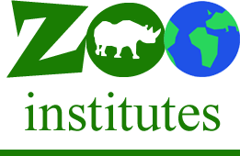
Adoption Form
- What animal would you like to adopt?
- Payment Amount
- First Name
- Last Name
- E-mail Address
- Cellphone Number

(Adapted from: www.jhbzoo.co.za)

